2.3 Resume Builder Desktop
Desktop View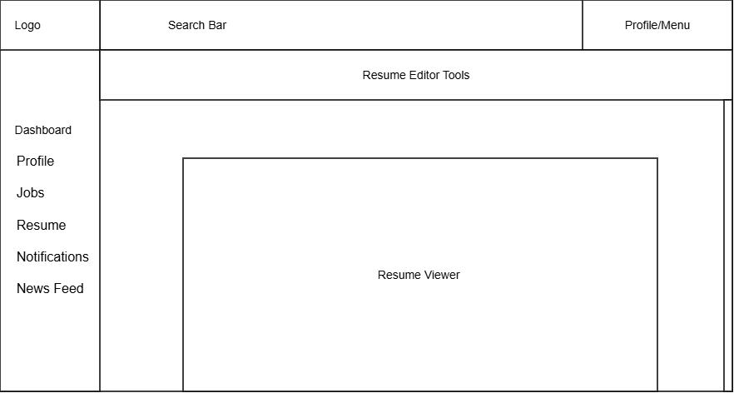

Design Information

Field | Description / Purpose
View Name & Number | 2.3 Resume Builder Desktop
Purpose / Design Concern | Provides a space that allows students to view and edit their resume that is to be used.
Description | Displays student’s resume and gives tools to make and save changes to the resume.
Requirements | SRS 3.5 Resume (3.5.1–3.5.5.2)
Elements | Logo
 | Search Bar
 | Profile/Menu
 | Dashboard
 | Profile
 | Jobs
 | Resume
 | Notifications
 | News Feed
 | Resume Editor Tools
 | Resume Viewer
Inputs | Resume Edits
Outputs | Resume reflecting saved changes and recent changes made
Navigation / References | Profile/Menu, Dashboard, Profile, Jobs, Resume, Notifications, News Feed
Viewpoint | UI Wireframe / Mockup (Desktop)

